Lab 1: HTML
RECAP

Task 1: Setup Notepad++
HTML files can be written in any text editor. For this module, I would prefer you to use a basic text editor to create the code yourself from scratch (i.e. not an application that generates the code for you, such as Dreamweaver).
If you are working from home, you could use Notepad or any basic text editor to create and edit your files. However, you might want to try software such as Notepad++, which provides syntax highlighting and auto-completion which can be useful.
Find Notepad++ in the Program menu now, or install it from the Application Catalogue if it’s not there.
When you launch the application, go to ‘Language’ in the menu, and choose ‘HTML’.
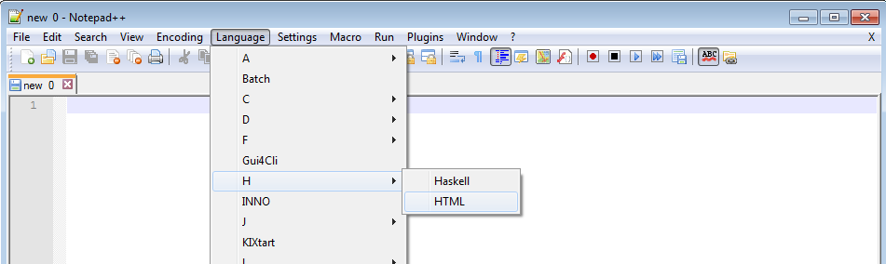

Always remember to save your HTML files with the extension ‘.html’
If you are editing a file in Notepad, it may default to saving the file as .txt – this will not then display as you want it to in the browser!

Task 2: Create a basic web page
In the lecture I explained how HTML ‘tags’ (or elements) are used to mark up the content. Look back at the lecture slides if you can’t remember how this worked.
Start by adding the following elements into your page:
<html> <head> <title> <body>
You will need to provide closing tags for these elements at the correct points (again, check the lecture slides if you can’t remember how).
Note that tags are not case sensitive (<html> will work just the same as <HTML>), but it is considered better practice to use lower-case text for html elements.
Once this is done, add some content into your page –
- give it a title of ‘My First Page’
- add some content into the body of your page – use http://www.lipsum.com/ to generate 5 paragraphs of text
- specify the start and end of each of the 5 paragraphs using the <p> element
Open the page in your web browser of choice and check it displays properly.

If you aren’t sure how to complete this task, be sure to ask your tutor for help before moving on to the next task.

Task 3: More features
You’ve created a very basic page – now let’s make it a bit better.

Heading
Place a heading on your page using the <h1> element. A heading of ‘Lorem Ipsum’ would be appropriate for example.
Add a suitable sub-heading for your third paragraph.

Links
I mentioned in the lecture that the web is built on the idea of ‘hypertext’ – pages of information with links to related content. It’s very rare to see any pages that don’t use links. Let’s add some simple ones now.
First, add a link at the bottom of your page to the Lorem Ipsum generator using the <a> element, with the ‘href’ attribute used to specify the URL. This should look something like this:
<a href="url_goes_here">Link text goes here</a>
Give some sensible name for your link text, and check that the link works in your browser.

Tip: it is bad practice to use text such as ‘click here’ for links. Links should always provide a useful description of what the link leads to, and can be read as a normal sentence for any screen readers. For more on this, see https://www.w3.org/QA/Tips/noClickHere

Now, create a second html page called ‘page2.html’ – make sure that it also contains the same basic html structure as your first page, but it doesn’t need to contain any text content yet.
Add a link to page2 on your first page, and a link back to the first page on the second page. Try to make your navigation clear and consistent for your users!
Note the difference between local or ‘relative’ links and ‘absolute’ links. To link to an external website (or image), you’ll use the full address, like so:
<a href="http://www.uclan.ac.uk">UCLan</a>
To link to content on your computer, just use the name of the file, like so:
<a href="page2.html">Page 2</a>
This will assume the file is in the same folder as the page you have put the link in – if it is in a different folder you will need to specify the path, like so:
<a href="week2/page2.html">Page 2</a>
If this isn’t clear or you would like a demonstration of this, just ask your lab tutor.

Images
Now let’s add some images. Using the <img> element, place two pictures on page2:
- The image that is on the VLE– save this in the same folder as your html file. You can then just use the filename as the source for the file
- You can enter the image address on the VLE (http://vle.furness.ac.uk/pluginfile.php/126820/mod_resource/content/0/lolcat.jpg) – or download the image, and link the file location in your html code.
Use the ‘src’ attribute to specify the name/location of the file, and the ‘alt’ attribute to give some sort of description for the image – look back at the lecture slides if you can’t remember how to do this.
The <img> tag should look something like this:
<img src = “location/name_of_file” alt = “description of file”>

Comments
As with any code files, it’s good practice to include comments. In html, these take this format:
<!-- this is a comment -->
These will be ignored by the browser when it processes the code, so they shouldn’t display to the user.
Add a comment at the top of each page to say who created the page, the date, and a brief description of what is on the page. Check that these comments are not visible when you load the page in your browser.

Validation and doctypes
Now, there is one small error with your html code that needs fixing. If you go to https://validator.w3.org/ and try to check your code, you will see one error that comes up. This is due to a missing ‘doctype’ declaration. Add this line to the top of your code on each page:
<!DOCTYPE html>
This is not actually an HTML tag – it is an instruction that tells your web browser what type of file to expect. Using HTML5, this is very simple – you just tell the browser that the doctype is ‘html’. In previous versions of HTML this may have looked more complicated (see http://www.w3schools.com/tags/tag_doctype.asp for some examples of these), but we won't be using those in this module.
Now this line is added, run your code for both pages through the validation tool again and check there are no errors. If you have any, try to fix them now.

Task 4: Adding more
There are many more features you might want to add into your html, and we don’t have time to cover all of them in this module. Now that we’ve covered the basics, you should be able to look up how to implement them yourself.
For example, try adding in the following features. Look at the links for examples of the elements needed in each case.
- An unordered bullet-point list (http://www.w3schools.com/tags/tag_ul.asp)
- A table of information (http://www.w3schools.com/tags/tag_table.asp)
- A drop-down list of items to choose from (http://www.w3schools.com/tags/tag_select.asp)

Task 5: Some quick styles
Let’s start by adding some quick styles to a basic web page. Use the page you created in last week’s lab, or copy and paste the code below into a new file (e.g. save as ‘lab2.html’).
<!DOCTYPE html>
<html>
<head>
<title>A stylish page</title>
</head>
<body>
<h1>Welcome to my stylish page</h1>
<p>Lorem ipsum dolor sit amet, consectetur adipiscing elit. Aenean augue eros, mollis sed neque sed, dapibus dignissim urna. In quis eros et purus dapibus hendrerit vel elementum tellus. Vivamus interdum ante sit amet pretium mattis. Sed tempus placerat lobortis. Quisque nec massa lectus. Nunc consequat in urna sed blandit. Curabitur nibh dui, rhoncus in purus in, varius luctus arcu. Donec at quam fermentum, convallis massa in, vulputate dui. Sed nec lacus eu orci laoreet fringilla. Quisque ante augue, gravida sed tincidunt et, blandit sit amet lectus. Sed aliquam felis semper, efficitur neque scelerisque, imperdiet urna. Nulla vestibulum dolor at nulla tincidunt gravida.</p>
</body>
</html>

Now let’s add some style to some of these elements.
Remember, styles are applied by using a selector (e.g. the html element you want to apply the style to), a property (e.g. colour, size, position etc.) and a value (what style you want to apply). Look back at the lecture slides for more examples of these.

Inline styles
We could add formatting information using inline styles, where the style information is included as an attribute of the html element. For example:
<h1 style="font-family:verdana; ">Welcome to my stylish page</h1>
Make this change in your html file, and reload the page in your browser to see the effect.
This is a quick and easy way to add style information to an element, but I explained in the lecture why this would be bad practice – the strength of CSS comes from its ability to assign styles consistently to a whole site without having to change each element individually.
Remove the style information that was added using inline styles before continuing.

Internal stylesheets
We could also define a stylesheet for each page. For example, use the <style> element within the header of your page, as so:
<head>
<title>A stylish page</title>
<style>
h1 {
color: red;
}
p {
font-family: verdana;
}
</style>
</head>
Make this change in your html file, and reload the page in your browser to see the effect.
You should see that this applies to all elements on a page – if you add in more headings or paragraphs, the specified style will be applied to all of them. This can be quite powerful.
However, we would need to change the stylesheet for each page in order to keep our sites consistent, which might be time consuming and prone to errors. Therefore, as a general rule we will try and use instead a third method of styling our pages, as we will see now.

External stylesheets
Create a new file called ‘simpleStyles.css’ (be sure to have the right file extension). In this, paste everything that was contained in the <style> tags in the previous example (not including the <style> tag itself) – i.e. the style information for the headings and paragraphs.
Now, remove the <style> tag from your html code (and all that is contained within it). In its place, put this line instead:
<link rel= "stylesheet" href= "simpleStyles.css" type= "text/css">
(If you have given your css file a different name, change the href attribute accordingly.)
Make these changes, and reload the page in your browser to see the effect. You should see that the page displays the same as when using the embedded internal stylesheet, but now you have just one file that could be linked from any page in your site. This is now using a powerful method of styling your pages that allows you to be consistent across all pages, and to make changes quickly.

Task 6: classes and IDs
In the lecture, I introduced classes and IDs as methods for applying styles in particular instances (look back at the slides if you need an explanation of these).
Try this now:
- Create a second paragraph of text (any text will do).
- Modify the html so that paragraph element is assigned to a class called ‘highlight’.
- In your stylesheet, define the style for the ‘highlight’ class as having a background colour of yellow (the property is called ‘background-color’).

Now assign an ID of ‘firstHeading’ to your <h1> element. In your stylesheet, define the styles for the firstHeading ID, using the following style:
text-decoration: underline;

Make these changes, and reload the page in your browser to see the effect.
Note: as you learn more CSS, you’ll find that there are ways of assigning a style to the first instance of the h1 element, without having to assign an ID to it. Have a look for some tutorials if you want to get ahead and see how to do this!

If you are not sure how to complete any of these steps, look back at the lecture slides or try looking at http://www.w3schools.com/css/default.asp.

Task 7: Create a navigation menu
We are now going to see an example of how CSS can be used to create some useful design features.
First, add in a bullet-point list into the body of your page, with 4 list items like so:
<ul>
<li>Page 1</li>
<li>Page 2</li>
<li>Page 3</li>
<li>Page 4</li>
</ul>

This will represent a menu of links to other pages on your site.
Change the html so that the text of each list item is a link to another page. Look back at last week’s lab if you can’t remember how to make a link. (You do not need to actually create the pages that each link points to.)
Your menu should now appear something like this:
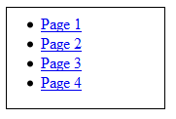
This is not a particularly nice looking menu!

In your stylesheet, add the following styles:
This removes the bullet points
ul {
list-style-type: none;
}

li a {
display: block;
text-decoration: none;
width: 80px;
background-color: #bbbbff;
}

This removes the underlined text

Here we are adding styles to all <ul> elements, and the <a> elements (links) that are contained within a <li> (list item).

Modify the styles so the link text is black, not blue.

Now reload your page – it should look something like this:
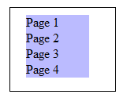
You will notice that the ‘block’ display means the whole line acts as a link now, not just the link text.
Now let’s add a nice feature – we can use what is known as a ‘pseudo-class’, which are pre-defined special states of certain elements. For example, we can create different styles for when a user hovers the mouse over a particular link, as so:
li a:hover {
background-color: white;
}

Add this into your stylesheet, and reload the page in your browser to see the effect.

There is quite a lot going on here – don’t worry if you don’t understand all of it at this stage, but hopefully you can see how CSS can be used to make some quick changes that greatly affect the look and feel of a page.
Stuck? Have a look at http://css.maxdesign.com.au/listutorial/roll_introduction.htm for a quick tutorial on making a rollover navigation list.

Task 8: Validation
We’ve already covered how to ‘validate’ your HTML code, or check that it conforms to the specification correctly (e.g. through https://validator.w3.org). You should know that you can also validate your CSS stylesheets in the same way.

Try this now: check your stylesheets using the validator at https://jigsaw.w3.org/css-validator/ and check that all your code is correct. If there are any errors then see if you can fix them, or ask your tutor for help if necessary.

Task 9: More features – UP TO HERE
Now test your understanding by adding the following features into your page:
- Change the background colour of your page to a pale blue/grey (paler than the navigation menu) (see https://www.w3schools.com/colors/colors_names.asp for a list of colours you could use)
- Change the style for your heading so that the text is black, and centred (see http://www.w3schools.com/cssref/pr_text_text-align.asp)
- Change the style for your paragraphs so the text is fully justified (see http://www.w3schools.com/cssref/css3_pr_text-justify.asp)
- Add a 1px solid black border around your menu list items (see http://www.w3schools.com/cssref/pr_border.asp)
- Don’t forget to add some comments into your CSS file – e.g. a block at the top saying who wrote it and when.
- Some styling elements you may want to look up and recap are:
- (http://www.w3schools.com/css3/default.asp )
- position
- top
- align
- width
- margin
- margin-right
- margin-left
- margin-bottom
- padding
- padding-top
- padding-bottom
- float
- clear
- text-decoration
- font-family
- border-bottom
- border
- list-style-type
- text-align
- font
- box-shadow
- border-radius
- z-index

- Remember, when specifying sizes (e.g. width), you may want to do so as a percentage, in order to provide a fluid layout that will allow the browser to be resized.

Task 10: Formatting text
This task is a bit of a challenge for you. The paragraphs below form a typeface sampler containing pangrams: sentences which use every letter of the alphabet in order to demonstrate how fonts will appear. Formatting text in Word is easy, but can you reproduce this in a web page? Use headings for the name of each typeface and check that your HTML and CSS validate correctly (see https://validator.w3.org/ and https://jigsaw.w3.org/css-validator/).
As always, it is best practice to put your styles in a separate stylesheet, although you can use the <style> element in the header if necessary for testing. Avoid using inline styles though – you could use IDs or classes to identify each paragraph.

Verdana 12-point
The quick brown fox jumps over the lazy dog.
The quick brown fox jumps over the lazy dog.
The quick brown fox jumps over the lazy dog.
Type: sans-serif

Georgia 14-point
Grumpy wizards make a toxic brew for the jovial queen.
Grumpy wizards make a toxic brew for the jovial queen.
Grumpy wizards make a toxic brew for the jovial queen.
Type: serif

Courier New 12-point
Jumpy Halfling dwarves pick quartz box.
Jumpy Halfling dwarves pick quartz box.
Jumpy Halfling dwarves pick quartz box.
Type: monospace

Stuck? You will need to work out how to achieve the following styles:
- Change the typeface
- Change the font size
- Switch to a bold font
- Switch to an italic font
- Align text to the left or right
- Change the background colour
Some of these we have covered before, so look back at previous worksheets or your lecture slides if you can’t remember how to do it. If you can’t find how to do something then try looking at these links for tips:
https://www.w3schools.com/css/css_text.asp
https://www.w3schools.com/css/css_font.asp

Task 11: Resizing Images
In the lecture we looked at some different image formats and their suitability for different types of media. We can demonstrate this now as we practice some simple HTML techniques.
In your web page, add the following links:
<img src="http://vesta.uclan.ac.uk/~lmcknight2/smiley1.jpg" width="500" height="500">
<img src="http://vesta.uclan.ac.uk/~lmcknight2/smiley2.svg" width="500" height="500">
You can check that the images display in your page… however this is not valid HTML! Can you spot what's missing? Fix the code so it validates (https://validator.w3.org).

These two images probably look fairly similar at this size. Change the size to 500 pixels for both images – can you see the difference now?

Your browser can also zoom into a page – in your browser's settings menu, set the zoom to at least 300% (ask your tutor if you are not sure how). The difference now should be clear. When you are designing a page, you should always consider how the page might look if someone views the page at a different size (as many people do!).
You might notice that we set the width and height of images using attributes within the <img> tag. This is valid HTML, but may be poor practice for two reasons:
- If the browser sets the size of the image, it will download the full-sized image, which may not be necessary. If you are making the image smaller in the browser, consider resizing it in a graphical package, as this will then require less data to be downloaded by the user.
- Attached stylesheets may alter the size of the image. It may be better practice to specify the size of images using styles. See https://www.w3schools.com/html/tryit.asp?filename=tryhtml_images_style for a demonstration. Change your page so the image sizes are specified using CSS and check that it still displays as expected.

Task 12: Hexadecimal codes exercise
Often when we’ve specified colours in CSS we’ve used named values, like so:
color: black;
There are in fact over 140 named colours that will work in all browsers – you can see a list of them at https://www.w3schools.com/colors/colors_names.asp or a nice tool to explore them at http://www.colors.commutercreative.com/.
However, sometimes we want to mix our own colour shades, in which case we’ll need to be more precise, and specify the individual values of Red, Green and Blue that make up that colour.
(CSS3 also allows the designer to specify other properties, such as the opacity, lightness or saturation – see https://www.w3schools.com/css/css3_colors.asp for more information.)
If you are specifying colours by their Red, Green and Blue values, it is common to use hexadecimal digits instead of decimal numbers, so we can store the same amount of information in less space.
For example, if you were styling the body of your web page, part of your code might look like this:
body {
background-color: #9a564b;
text-align: center;
}

Remember: one hex digit can store 16 possible values (0, 1, 2, 3, 4, 5, 6, 7, 8, 9, A, B, C, D, E or F)
2 hex digits can therefore store up to 256 possible values (16 x 16)
If you had a red value of ‘15’ in decimal, this would be represented as 0F in hexadecimal.
The value ‘FF’ would be the same as 255 in decimal.
Look back at your lecture slides or ask your tutor if you are still confused by this.

Here are some tests to check your understanding of this – fill in the blanks:
- If the colour value is set to #9a564b then the highest value is _______
(answer Red, Green or Blue)

- If the colour value is #0020FF, this is the same as saying:
Red = ____, Green = _____, Blue = _____ (in decimal)
(Tip: the Windows calculator can convert between decimal and hexadecimal values – just make sure it is in ‘programmer’ mode. )

- The colour values are Red = 255, Green = 255, Blue = 0.
The hex code would be: #___________
And the colour would be: ___________

- The colour white is written as #__________

- What might be the code to make a pale grey?
Answer: #___________

Task 13: Special characters

Basic characters
We talked in the lecture about displaying special characters. This might include emoji or international characters, but can also include some fairly standard symbols.
Try this: in your HTML source (you can use the template at the start of this document to start a new file, or keep working on an existing page), add this line:
<p>Try our special ‘all you can eat’ menu – today only £4.99!</p>
Look at the page in your browser – does it look right? Try a few different browsers (e.g. Chrome, Firefox, IE or Edge).
Chances are, in at least some browsers your page looks a bit like this, which clearly isn’t right:
Luckily, this is quite easy to fix!
The first thing to do is to tell the browser how your characters are encoded. You can do this by adding this line into the header (somewhere between the <head></head> tags) of your page:
<meta charset="UTF-8">
UTF-8 is a character encoding method that can represent any character in the Unicode standard. For more details, see here: https://www.w3schools.com/charsets/ref_html_utf8.asp
Refresh the page: you might find that the bug is fixed already!
(And you might find that this also fixes an error you’ve been seeing when you validate your HTML!)
You could also use an HTML code to define the special characters, like so:
<p>Try our special &#39;all you can eat&#39; menu &#8211; today only &pound;4.99!</p>
See for example this page for a list of codes that could be used: https://www.ascii.cl/htmlcodes.htm

Further Unicode
The current standard of Unicode supports 137,439 characters – what if we wanted to use some of them too?
Because emoji are essentially text characters, we can use them in the same way as many letters.
For example, you could just copy these lines and paste them into your source file:
<p>Hamburger: 🍔 </p>
<p>Burrito: 🌯</p>
<p>Pizza: 🍕</p>
If you’ve not forgotten to set the character encoding in the header, this should just work. You could then use a source such as Emojipedia (https://emojipedia.org/) to look up a character to copy and paste in.
Or, of course, you can look up the codes too, e.g.:
<p>Hamburger: &#x1F354</p>
If you want to try this more, the ‘codepoints’ for each emoji are shown on Emojipedia or the full list at https://unicode.org/emoji/charts/emoji-list.html -- to put them into HTML, take off the ‘U+1’ at the start of the code and replace with ‘&#x’.
If you want to read more on HTML tricks with emojis, try this page: https://www.kirupa.com/html5/emoji.htm

Task 14: Assistive Technologies
In the lecture I mentioned that it is important to support a range of different devices that users may be using. However, it can be hard to do this without any understanding of how assistive technologies operate! In this task, you will try out a few different technologies, so that you can understand the difference between them.

First, let’s see what you can do in Windows without installing any new software.

Enabling text-to-speech in Word
Look for the ‘Quick Access Toolbar’ at the top of this Word document, and click the down arrow (‘Customize Quick Access Toolbar’) as shown:

Select ‘More Commands’.
In the dialog box that appears, use the drop-down box to select ‘All Commands’, scroll down until you see ‘Speak’, select this and click ‘Add’.
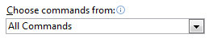
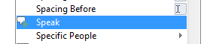
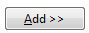
Now, you can select any text in your Word document, and then click the button in your toolbar to hear the text spoken aloud.
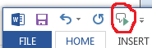

Try this now – how does the voice sound to you? Are there any words or features it struggles with?

Read Out Loud in Acrobat
This isn’t just a feature of Word – many applications support text-to-speech. For example, if you have a pdf document, Adobe Acrobat can read text aloud to you quite easily.
Open a pdf file from your computer in Acrobat now.
(Don’t have a pdf to hand? Go to ‘File’ in Word from this document and choose ‘Save as Adobe PDF’.)
In the ‘View’ menu, choose ‘Read Out Loud’. You can now either select text, which is then read automatically, or the ‘Read Out Loud’ menu offers options to read the whole page or the whole document.
Try this now – would this feature be useful to you when reading long documents? For example, you might have a lot of academic papers downloaded to read for assignments… ☺

You might notice that the speaker sounds the same in both applications! All these tools are using the voice that is currently installed on your operating system. To see what voices are available, go to the Control Panel, choose ‘Speech Recognition’ and then ‘Text to Speech’. This will also allow you to change the speed of the voice.
The built-in Microsoft voice doesn’t sound too great – other voices could be installed if you used this feature regularly!

Screen Readers
It’s important to understand the difference between text-to-speech tools and screen readers. The text-to-speech tools you tried above read out portions of text within an application, to aid with reading or comprehension – a screen reader is designed to read out the entire contents of the screen, including identifying the application and allowing the user to navigate the operating system. You might use a text-to-speech tool to read sections of a website aloud to you, but a screen reader would read the entire contents, line-by-line, in the order they are presented in the code (which is not always the same as the visual order). It is expected that screen readers are used with keyboard input, not a mouse.
Watch this video: it gives you a brief demo of how a popular screen reader called Jaws is used to browse a website.
https://www.youtube.com/watch?v=-GPNTctdezg
Note the tips for website designers – these may be useful for your assignments…

There are many more demo videos of Jaws to be found on YouTube, or if you want to try a screen reader for yourself, there are a few options available.
A very basic screen reader is included with Windows, called Narrator. Go to the Start Menu, and type ‘Narrator’ in the search bar. Give this a try if you have time – you will need to use keyboard shortcuts to use it correctly (see https://support.microsoft.com/en-gb/help/17173/windows-10-hear-text-read-aloud).

Task 15: Tips and Tricks

Overriding stylesheets
I mentioned in the lecture that users may override your CSS stylesheet, or turn styles off completely. Without using a text-only browser or screen reader, do you know how to turn off your stylesheets and check that users can still make sense of your page?
Obviously you could just comment out the lines of code that link to your stylesheet, but the Web Developer plugins for Chrome or Firefox may be useful here.
For example, if you are using Chrome, follow these steps:
- go to the Chrome Web Store (https://chrome.google.com/webstore/category/extensions) and search for ‘Web Developer’


- click ‘Add To Chrome’
- click the icon (at the top of your browser) to open the Web Developer toolbar
- in the CSS tab, choose ‘Disable All Styles’.
Try this now, and have a look at some popular websites to see how well they work without styles applied.

Keyboard Shortcuts
One of the accessibility guidelines we covered in the lecture mentioned making all functionality available from a keyboard. This wouldn’t necessarily apply for mobile applications (so isn’t essential for your assignment), but is still useful to know about.
A keyboard user will often use the tab key to navigate through a web page, pressing tab to bring focus to each item on the page in turn. The order that they will get focus depends on the order that they appear in the HTML source code. Therefore, to assist this, you should check that your source code follows a logical order, not relying on stylesheets to make sense of your page (see https://webaim.org/techniques/keyboard/ for more on this).
You can also add in access keys. Try this now: use your work from Week 4 where you created a page with some anchors to navigate within the page.
In your HTML code, add an ‘accesskey’ attribute to the link. E.g.:
<a href="#stuff" accesskey="s">
To use this you will have to press another key first – for example in Chrome you would then press Alt-t to use this keyboard shortcut (see https://www.w3schools.com/tags/att_global_accesskey.asp for a list of commands for other browsers). Check that this works. But also think – how might you let users know this feature exists?

Task 16: WCAG Guidelines
In this week’s lecture we looked briefly at the W3C Web Content Accessibility Guidelines (www.w3.org/TR/WCAG). We would hope your applications will adhere to these guidelines as far as possible, particularly when we start implementing more complex applications next semester, so it is important to become familiar with them, and think about how they can be put into practice.

The WCAG guidelines consist of 12 high level guidelines that can be given one of four possible ratings based on how well the site meets that guideline. These ratings are:
- Unrated – The website does not satisfy all of the basic level A criteria
- Level A – The website satisfies all of the level A criteria
- Level AA – The website satisfies all of the level A and level AA criteria
- Level AAA – The website satisfies all of the level A, AA and AAA criteria
There is a great deal of information on the W3C site explaining each of the 12 guidelines, as well as the criteria needed to meet each one. There is also advice and examples on how to meet each of these criteria (see diagram below).

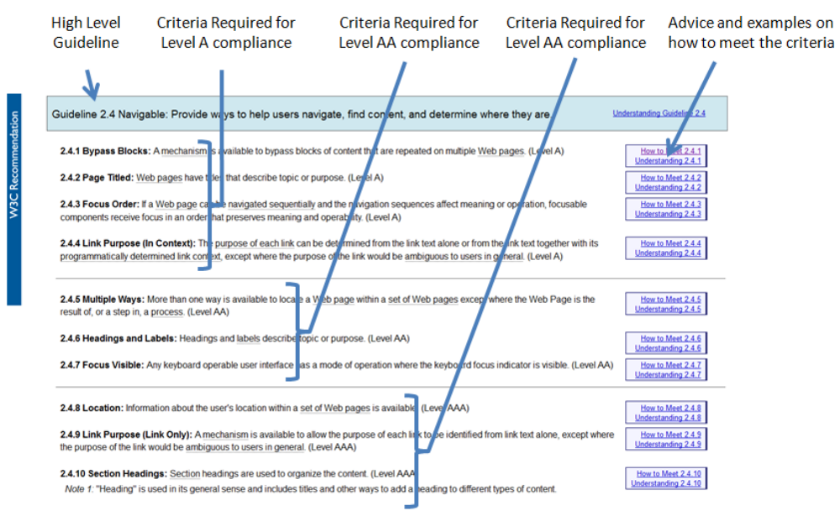

For this task you need to take a website of your choice and perform an accessibility evaluation of a page on your chosen website. The page must contain sufficient content to make the evaluation worthwhile.
Use the WCAG Guidelines (www.w3.org/TR/WCAG) as heuristics in your evaluation. You should state what level of compliance you believe each page meets for that guideline (look at the advice and example if you are not sure).
If a page does not meet one of the criteria in the guidelines, then list the problem and move on to the next high level guideline. If the page meets the criteria move down to the next criteria for that guideline. At the end, give the site an overall accessibility rating along with a brief explanation (no more than 1 paragraph) for your decision.
You should use the pro-forma provided on the VLE to help you with your evaluation.

You can work in pairs or small groups for this task if you like – it may be useful to discuss answers with others. However, make sure that one page is evaluated per person – if you are working in pairs, then evaluate 2 different pages, and so on.

Task 17: Going further

Challenge: throw away your mouse!
As mentioned before, not everyone uses a mouse. In fact, the mouse was originally designed as a specialist piece of hardware for experts only, but they became commonplace on desktop systems. However, even without the use of a touchscreen, you should be able to operate your computer entirely using your keyboard, and there are plenty of times when you might want to be able to do this (e.g. the mouse is broken, you can work faster using keyboard shortcuts, you cannot see the screen or you have difficulty moving the mouse accurately). Do you know how to do this already?
As a challenge, try to complete the list of tasks below on your pc without using your mouse at all. Think as well about the difference between usability and accessibility – the commands might be accessible via a keyboard, but how does this affect the usability?
Tasks:
- Open the Calculator, and calculate 7/2. Quit the application.
- Open Powerpoint. Create a new file, put some content on the title page. Create a new slide. Insert an image into this slide.
- Switch to Word (which should already be open – don’t open it again). Select some text on the page and have it read aloud.
- Open a web browser, and go to http://en.wikipedia.org. Search for WCAG. Go back to the home page, and access the day’s featured article.
Tip: the ‘Alt’ key and the ‘Tab’ key will be very useful to you for these tasks…
Think back to task 1 as well and the use of screen readers – do you think you could manage these same tasks if you also couldn’t see the screen?

Revisiting colours
In last week's lecture we looked at colours, but only briefly mentioned accessibility issues. Some of these we might now have covered – you should never be making any content that is reliant on people being able to see an interface the same way that you do.
However, there are times when you might want to check how your interface looks under different conditions. For example, there is a Colorblind Web Page Filter (http://colorfilter.wickline.org/) that will allow you specify a website and simulate how it may look with different types of colour blindness. Or, the Paletton website (http://paletton.com) will allow you to pick a colour scheme and see examples of how this might look on a web page, and then add different types of vision simulations to this, including different types of colour blindness or different types of display.
Have a look at these tools (they might be useful for your assignments), but always think as well how the content would look if you reduced it to text and removed the visual display entirely.

Automatic testing
There are various sites around that will aim to test a web page for accessibility, but many of them require a URL (which your pages won’t have yet) and some of the issues they raise might need fixes that we haven’t covered yet. However, if you want to try tools like this though on some common sites, they can hopefully help to show you some of the issues that can arise.
For example, take a look at http://wave.webaim.org/ or https://tenon.io/ -- you could enter http://www.uclan.ac.uk as the site to test!

Task 18: Flexbox image gallery
For this task, you are going to build a very simple image gallery. I have provided a template which contains the html content, along with a partially completed stylesheet and a folder of images. Download these from Blackboard now and check that you can view them.

First, we are going to fix the header so that it looks better. Add the following line to the .header, .date, .menu and .links classes in your stylesheet:
display: flex;
These divs now all act as flex containers. This means we can control the alignment of them using the ‘justify-content’ property.
Add this line to the .header class:
justify-content: flex-start;
And this line to the .date class:
justify-content: flex-end;
The .menu and .links classes should now also include this line:
justify-content: space-between;

Reload the page, and see how it looks. Your menu should now look something like this:
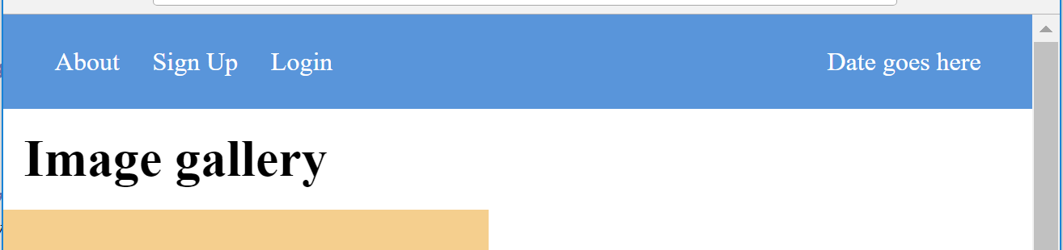
If you resize the page you should see that the date stays justified to the right of the page, while the three links in the menu stay justified to the left.

Now we can fix the images.
- Update the .content and .gallery classes to also use the flex display, as you have done above.
- Apply the ‘justify-content’ property with the value ‘center’ to the .content and .gallery classes in your stylesheet.
- Add the following line to the .gallery class in your stylesheet:
flex-wrap: wrap;
Reload the page and see how it looks – it should look something like this:
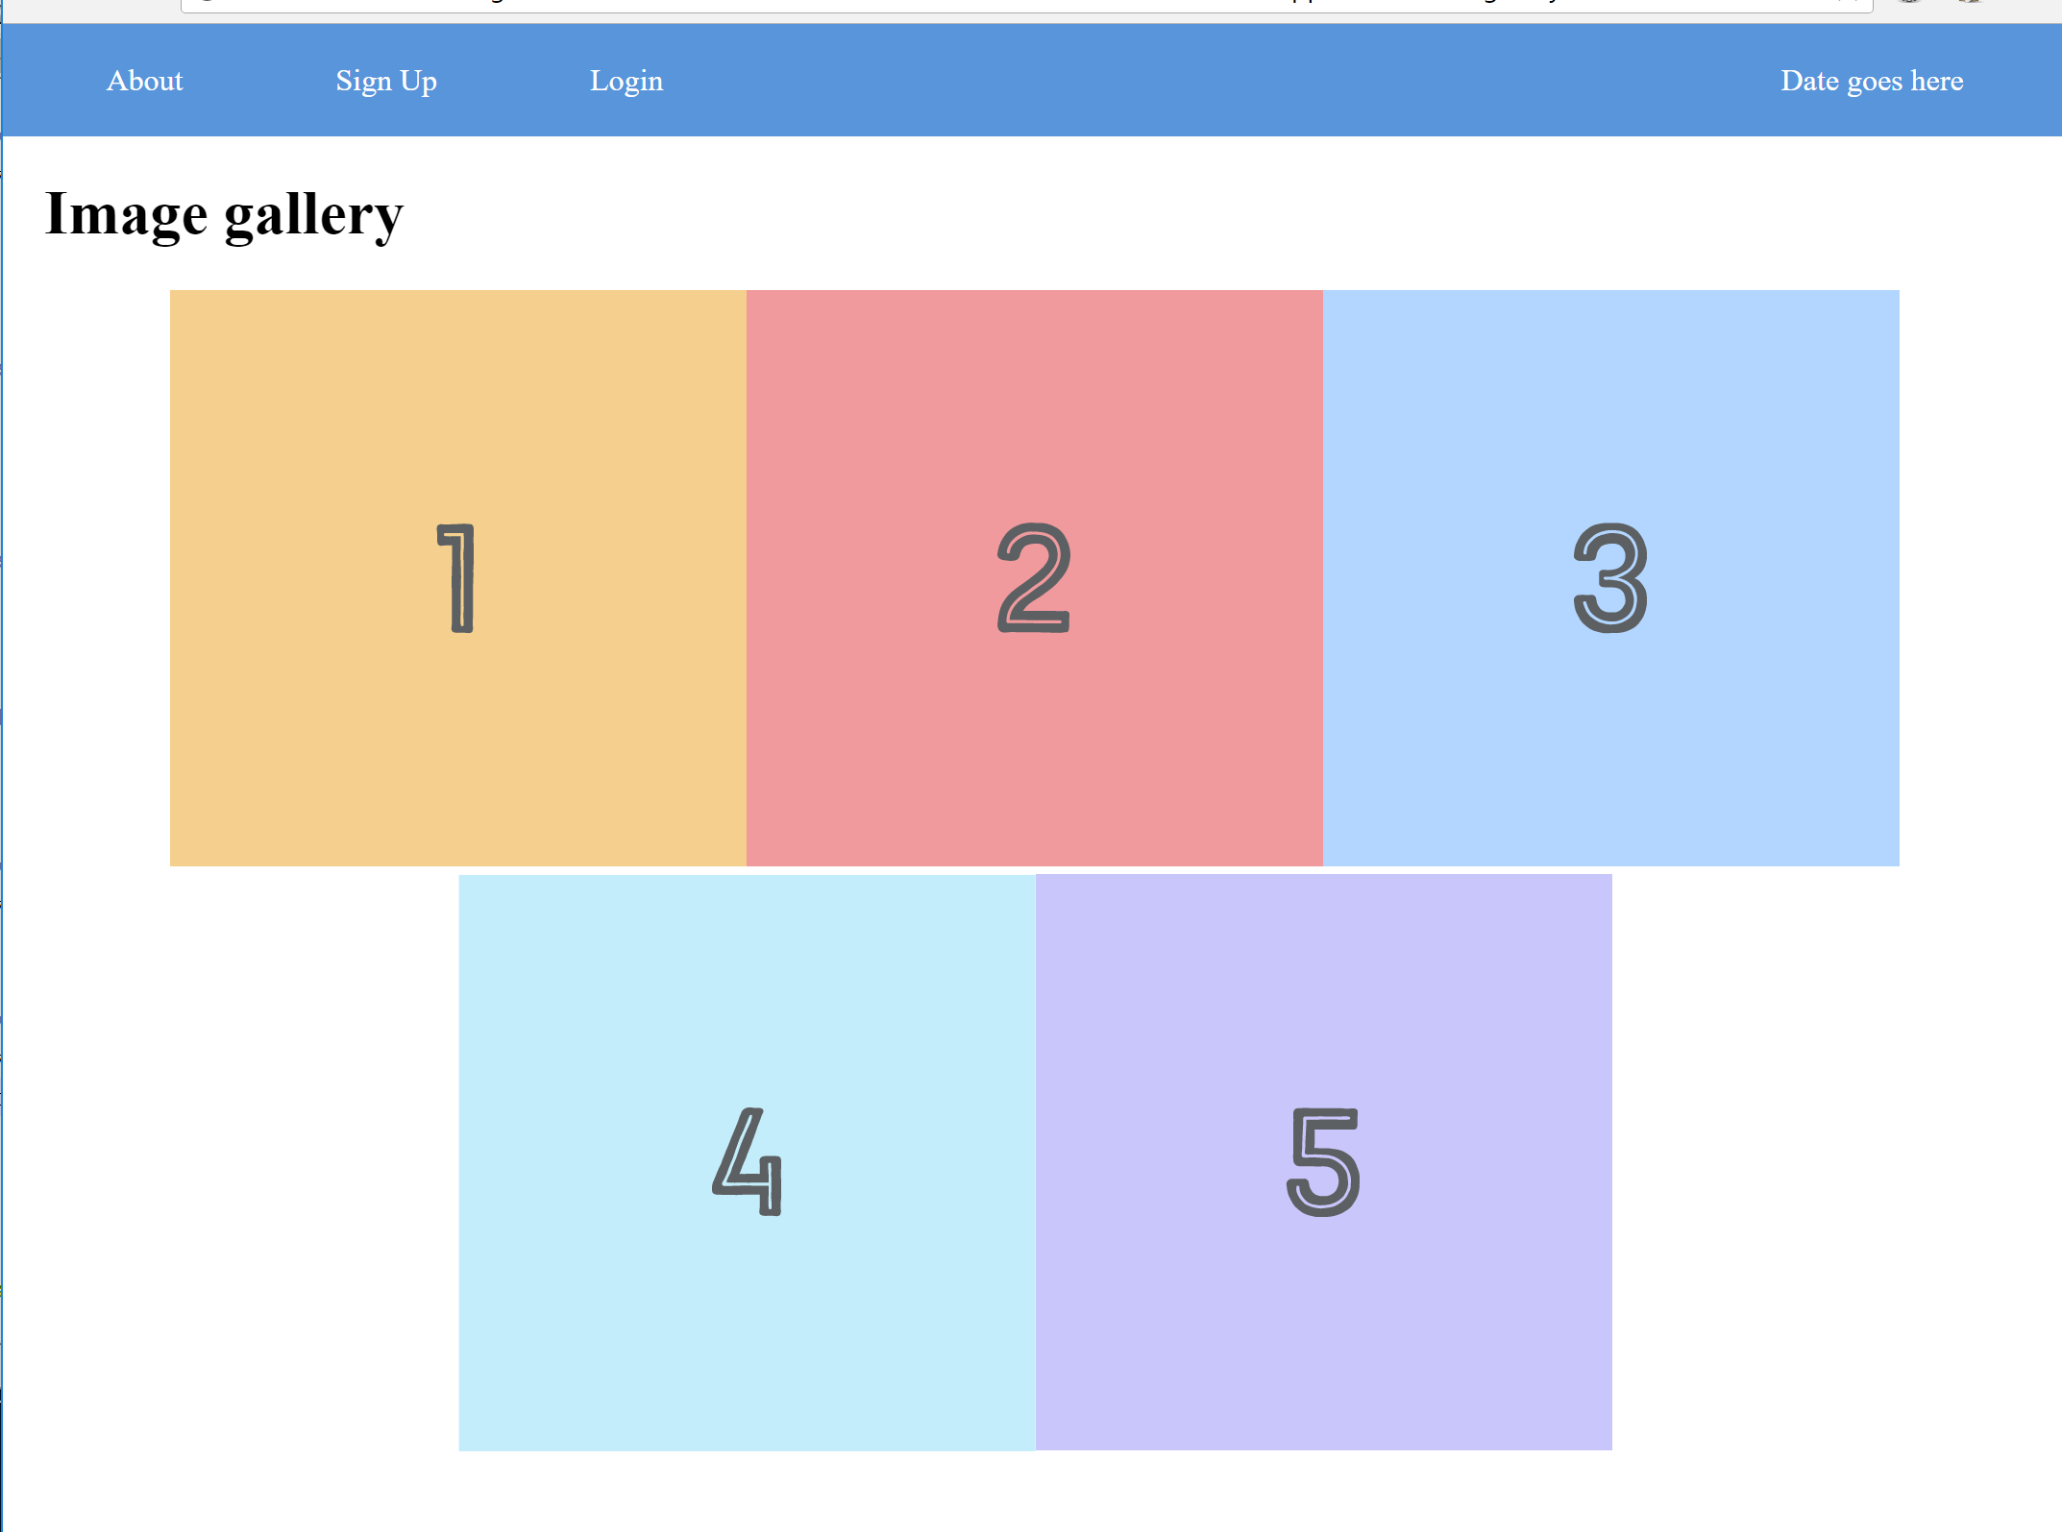
Try resizing the page and see how the images wrap to fit the size of the page. This would be pretty hard to achieve neatly using standard floats!
This example is taken from a tutorial at https://internetingishard.com/html-and-css/flexbox/ -- if you are interested, have a look and see how you can use the flexbox module to control the layout of your items further.

Task 19: Scripting practice
For this task, we are going to use the page we created in Task 1 to practice some of our scripting techniques. Try to complete the following exercises.
- The page should display the current date. This can be done with Javascript as follows:
- Create a variable and assign it to a new instance of the Date class
- Use the ‘toDateString()’ method to output the current date.
- Convert the pages to use the .php extension. Transfer the page to the server and check it still all displays as expected.
- The ‘gallery’ class contains 5 divs which are nearly identical, and quite a lot of repeated code. Use a for-loop to reduce this to one echo statement which will output all 5 lines.
- If you view the source of your php page in your browser, this generated code probably doesn’t look very neat. Add some formatting to your source code by inserting new lines within your echo statement (this is done with the characters \r\n ).
Check the page works as expected before moving on.

Task 20: Media queries
This exercise will give a short demonstration of how media queries in CSS can be used to change the content of the page depending on the nature of the device viewing it. It will be up to you to determine what features you might want to change and when!
A media query can contain any CSS styles within it, like so:
@media screen and (max-width: 400px) {
h1 {
color: red;
}
}
Note the nested brackets!
Follow the steps below to add different styles for some different screen sizes.
- Update the stylesheet for the page created in Task 1 to include a style for the background colour of the body, as so:
body {
background-color: white;
}
- Below this, add a further style using a media query – when the width of the screen is less than 800px, set the background colour of the body to ‘lightskyblue’.
- Below this, add one more style using another media query – when the width of the screen is less than 500px, set the background colour of the body to ‘blue’.
You should now have three definitions for the ‘body’ selector.
Reload the page in your browser, and resize the window to see that it works.
For more examples of how media queries can be used (including responsive image galleries and navigation bars), see this page: https://www.w3schools.com/cSS/css3_mediaqueries_ex.asp

Task 21: Security
In the lecture I discussed hashing – a one-way cryptographic function that encodes data so that it cannot be decoded. This can be very useful for storing passwords. The maths behind it is complicated, but the application of it in php is luckily quite straightforward!
For this task we will use the ‘hash’ function in php. This function accepts two string parameters (the algorithm to be used, and the data to be hashed), and returns a string representing the hashed value.
Follow the steps below:
- Create a php page on the server
- Add a simple form onto the page (the following code will be sufficient)
<form>
<input type="text" name="message">
<input type="submit">
</form>
- Within a block of php code, create a variable called $secret which holds the following string:
b94d27b9934d3e08a52e52d7da7dabfac484efe37a5380ee9088f7ace2efcde9
This is a super secret message to programmers that could be very difficult to guess. (If you can’t guess it, I can tell you the answer!)
- Create another variable called $guess which holds the data from the ‘message’ box in your form (using the GET method)
- Create a third variable called $hash which contains the result of hashing the guessed message. The algorithm to be used is "sha256".
- Compare the $hash variable with the $secret variable. If they match, display a message to say you have guessed the secret message!
- Tip: before you enter any data, you may see an error message – you may need to use the ‘isSet’ function to check if a variable contains any values before using it. This function takes the name of a variable as its parameter and returns true or false.
More help on the hash function can be found here: http://php.net/manual/en/function.hash.php
You could use this function to generate a hash of a user’s password (either when storing the password initially, or create a hash to compare against a stored value) – however, if you want to also add a ‘salt’ to your hashed password for additional security, this can be done using the password_hash function instead – this returns the hashed value and a randomly generated salt which you will need to store in your database. You can then also use the password_verify function to check a password against a hashed value. More details on this are available at http://php.net/manual/en/function.password-hash.php and http://php.net/manual/en/function.password-verify.php.

